Hello JP and all,

My Orthopaedic colleague was snowboarding yesterday and had a mishap which lead to a L shoulder dislocation. After reduction, the following imaging was obtained.

My colleague is a right handed Orthopaedic Surgeon who specializes in sports surgery (nondominant extremity).

He is receiving lots of advice and I thought this esteemed group could provide opinions.

Some of his questions:

NonOp vs Operate

If Operate:

  Scope Vs. Open

  Subscap split vs tenotomy vs peel

 cannulated screw vs Mini frag plate

He gave me permission to share his images.

Thanks

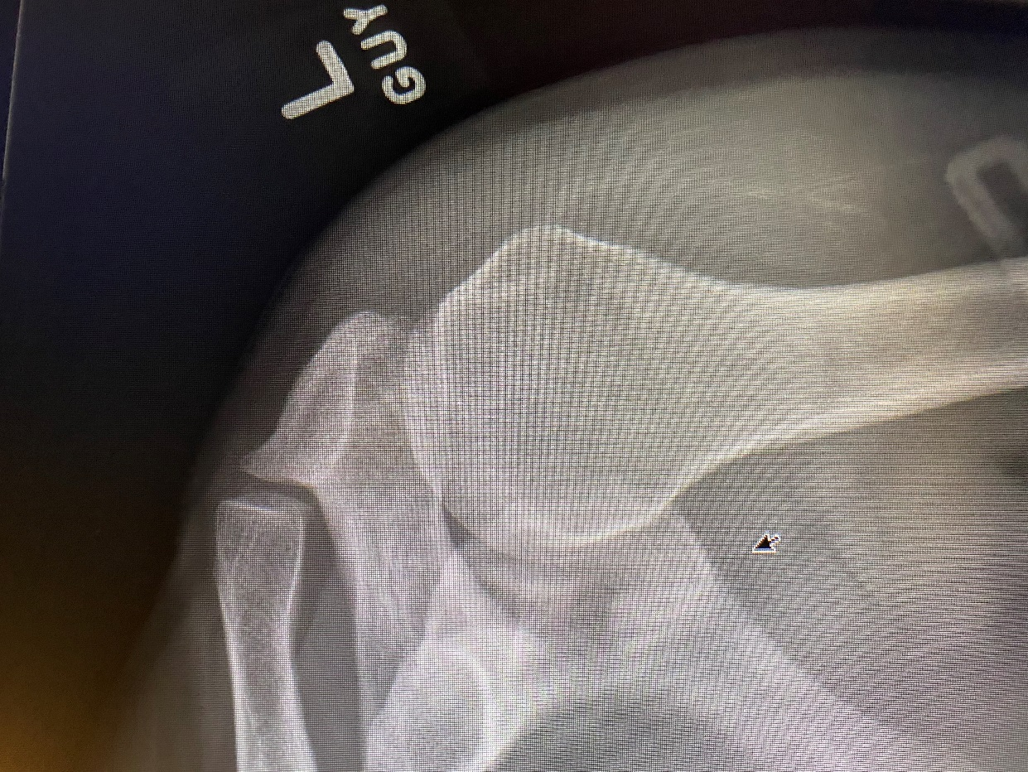

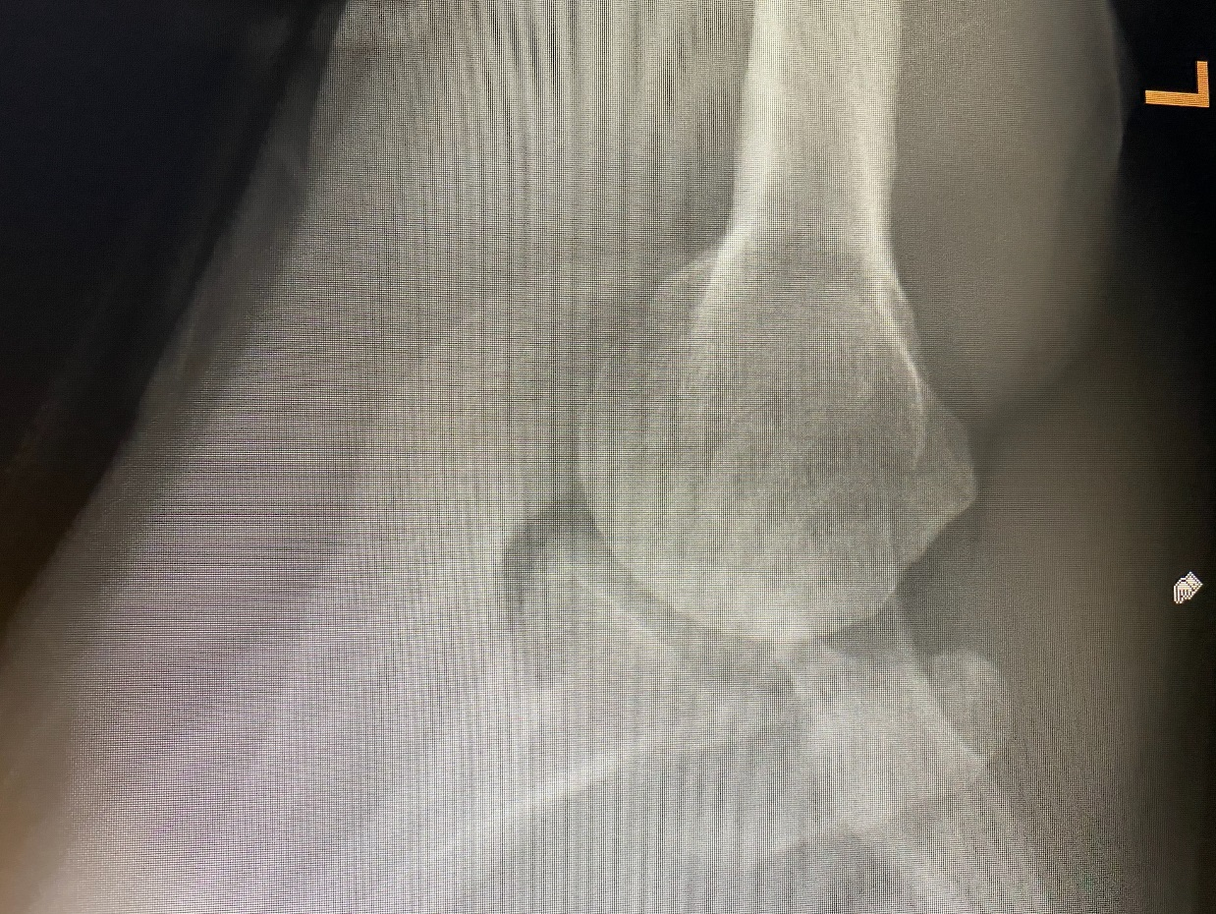

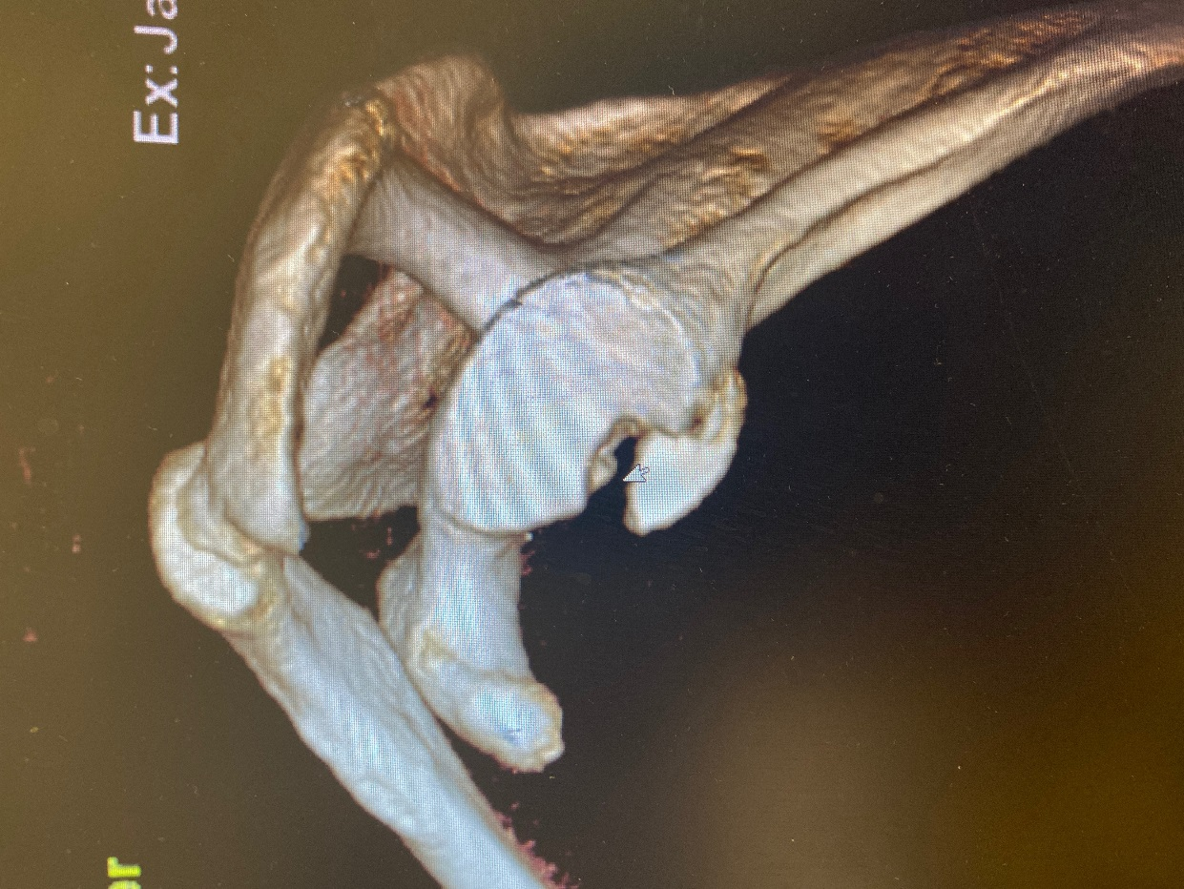

Best,

Ron

Ronald A. Navarro, M.D.  
[navarro.ortho@gmail.com](mailto:navarro.ortho@gmail.com)