8th Annual Meeting 2023

June 17, 2023, 4pm-8pm (Dinner Served)
Hotel Del Coronado | San Diego, CA

4:00-4:25PM Cocktail Reception
4:25-4:35PM Group Photo (Don’t be late!)

4:35-4:40PM Introduction to the Meeting & Speakers (JP Warner)

PART I: Innovators, Entrepreneurs, Behaviors and Culture

4:40-4:50PM Jon “JP” Warner: Welcome- Innovation & Entrepreneurship: What is it? Who does it? What structure and Culture Allow or Prevent it?

4:50-5:10PM Prof. Christian Gerber: “What drives Scientific Creativity and Innovation?”

5:10-5:30PM Dr. Lanny Johnson: “Innovation & Entrepreneurship: Scaling your idea outside the Box”

5:30-5:45PM Prof. Ron Adner: “The Wide Lens: What Successful Innovators See that Others Miss.”
5:45-6:00PM Prof. Ron Adner: “The Case of IPT: Digital Transformation in the Peri-operative Space.”
6:00-6:40PM Panel Discussion: C. Gerber, L. Johnson, R. Adner ; John Macy MD, Derek Haas (via Zoom)
Moderators: JP Warner & Porter Jones, MD, MBA

Part II: The Avant-Garde Health/CSS VBHC Research Group Update

6:40-7:10 Working Dinner & Presentation: Porter Jones, MD,MBA & Derek Haas, MBA (via Zoom)

Part III: Leadership & Career Development

7:10-7:20PM Dr. Jon JP Warner: Introduction:

7:20-7:40PM Mr. Alan Friedman: “Using a Data Based Approach to Innovation, Collaboration and Outcomes”
7:40-8:10PM Panel Discussion: David Jevsevar,MD, MBA (CEO, OrthoVirginia) Tim Lanier, VP & GM Stryker Upper Extremity, Benjamin A. Byers, PhD, Global Marketing Director, Soft Tissue Solutions, DePuy Synthes, Johnson & Johnson

End of Meeting

Speaker’s Bios:

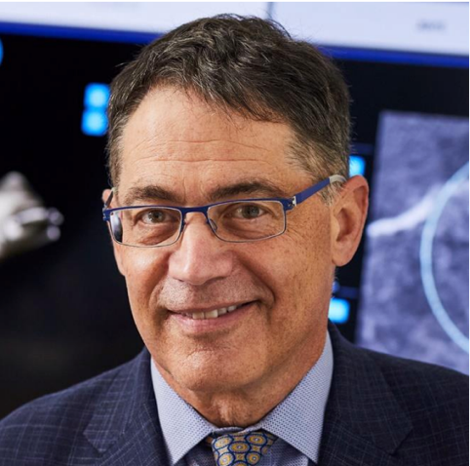
Jon “J.P.” Warner, MD is The Co-Chief of the Mass General Shoulder Service, Vice Chair for
Quality & Safety for MGH Orthopedics and Professor of Orthopedics at Harvard Medical School.
He is the founder of The Codman Shoulder Society, a network of experts dedicated to
improving outcome for patients based on measurement, transparency, and research
collaboration. He is also the founder of the Boston Shoulder Institute, a patient portal for
education, measurement, and outcomes transparency. In addition, he founded the New
England Shoulder and Elbow Society, a not-for-profit educational program which fosters
collaboration among all shoulder and elbow surgeons in the New England Region. He is also
President elect of the San Diego Shoulder Institute, the oldest educational program for shoulder
surgeons.
Dr. Warner’s postgraduate education included fellowships in Shoulder and Sports Medicine
both in the United States and Europe. He is a graduate of the Executive Program (alternative
eMBA program) at Harvard Business School of which he is an Alumnus, Class of 2019.

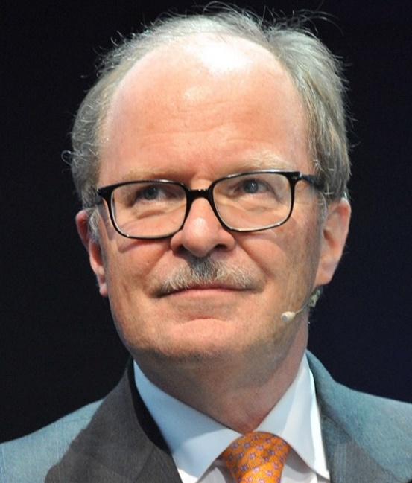
Professor Christian Gerber is Emeritus Chair of Orthopedics at the Balgrist Klinik, University
of Zurich, and Founder and Director of the RESORTHO Foundation, Balgrist Campus Research
Center, and the Dominik Meyer Award for Discovery, Innovation, and Disruption in
Orthopedics. He is arguably the most influential surgeon of his generation as he personifies the
surgeon scientist. His work has been honored with numerous awards including his Kappa Delta
OREF Clinical Research Award (First Non-American Awardee) for his body of work on Rotator
Cuff Tear Treatment: Bench to Bedside. He is one of the few researchers to win the esteemed
Neer Award of the American Shoulder and Elbow Society (ASES) four times. He is also the
recipient of the Didier Patte Award of the European Society for Shoulder and Elbow, Silver
medal of Merrit of the state of Zurich (for extraordinary achievements in science), Arthur
Steindler Award of the Orthopaedic Research Society, and many more. He has published 475
original research papers and has an H-Index of 109 with 43,300 Citations (Google Scholar). He
has been an invited lecturer for societies and meetings all over the world.

His research has resulted in paradigm shifts for shoulder care and include the first description
of isolated subscapularis tendon tears, the development and application of latissimus dorsi
transfer for irreparable rotator cuff tears, the patho-anatomy and etiology of rotator cuff tears
and the optimization of surgical repair strength, the durability of Latarjet procedure for
shoulder instability, the etiology and solution for refractory posterior shoulder instability, the
classification of proximal humerus fractures and the natural history of avascular necrosis,
techniques for shoulder arthroplasty, and many more. He has also developed many products
including shoulder arthroplasty implants and instruments for shoulder surgery.

Most importantly, he has inspired and educated an entire future generation of surgeon scientists
who will carry on with his unique combination of curiosity and scientific discipline in order to
improve the lives of orthopedic patients.

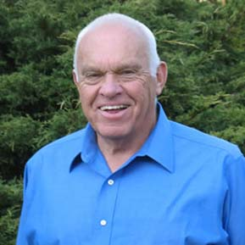
Over the course of his career in private practice, Dr. Lanny Johnson’s focus has been upon patient care and making it better. He is certainly one of the most successful innovator entrepreneurs in Orthopedic Surgery. As such he was one of the pioneers in arthroscopic surgery with the invention of the motorized instrumentation. He was perhaps the first to offer a primitive method to stabilize the shoulder. He likely was the first to demonstrate the arthroscopic technique for the elbow, wrist, hip, ankle and even the temporal mandibular joint. His patient focused interest coupled with curiosity and vision resulted in over 80 US patents related to orthopedic surgery, i.e., bio absorbable implants.

His interests expanded to developing an Electronic Medical Record (EMR) in 1980 to create a more efficient practice. The data provided by the EMR allowed him to know outcomes and the value of his practice. This led to a novel means of controlling one’s practice by offering to insurers, a package care product with a fixed fee less than present profile including a financial warranty that was published in Arthroscopy. This was likely the first ever Surgeon-designed Bundle for arthroscopic surgery.

Over the course of his career, he was visited by many notable surgeons whom he greatly influenced. This includes Freddie Fu, James Andrews, and many others.

Since concluding his clinical practice in 1996, he has morphed to a basic scientist exploring the potential of a phytochemical, protocatechuic acid (PCA). This benzoic acid is found throughout nature, common to the human diet and manufactured in small amounts by the bacteria in the human large bowel. The FDA has determined that PCA is generally recognized as safe (G.R.A.S.). Now with more than 20 patents on the potential clinical applications; a broad-spectrum antibiotic, a biofilm destroyer and antiviral for SARS CoV2 and other encoated virus. Even more surprising is the anabolic nature of PCA. It has been shown to turn on the gene for IGF-1 in human and animal synovium. It has the potential to be a DMOAD. In addition, there is basic science evidence that PCA causes human osteoblasts and mesenchymal stem cells to produce bone, i.e., fracture healing and treatment for osteoporosis.

In between, in recent years he had a 10-year stent as a certified instructor on the PGA tour.

Ron Adner is The Nathaniel D’1906 and Martha E. Leverone Memorial Professor of Business Administration and Professor of Strategy and Entrepreneurship at the Tuck School of Business at Dartmouth College. Prior to joining Tuck, he was the Akzo-Nobel Fellow of Strategic Management at INSEAD, where he served on the faculty for ten years.
Dr. Adner’s award winning research introduces a new perspective on value creation and competition when industry boundaries break down in the wake of ecosystem disruption. His two books, The Wide Lens: What Successful Innovators See that Others Miss (2012) and Winning the Right Game: How to Disrupt, Defend, and Deliver in a Changing World (October 2021) have been heralded as landmark contributions to the strategy literature. Clayton Christensen (Innovator’s Dilemma) described his work as “Path-breaking” and Jim Collins (Good to Great) has called him “One of our most important strategic thinkers for the 21st century.”
Dr. Adner is an elected Fellow of the Strategic Management Society. He has held editorial and board positions in the leading peer-reviewed academic journals of his field, including the Academy of Management Review, Management Science, the Strategic Management Journal, and Strategy Science. His managerial articles have been published in outlets including the Harvard Business Review, The Atlantic, Fast Company, Forbes, Wired, The Financial Times, and the Wall Street Journal.
Dr. Adner’s work is a rare convergence of rigorous academic research, profound managerial insights, and practical, powerful frameworks. Applied, tested, and validated in some of the world’s leading companies, his approach to seeing the bigger strategy picture has been transformative in driving effective innovation in both the corporate and social sectors.
Dr. Adner is founder of the Strategy Insight Group, whose mission is to help clients eliminate strategy blind spots and build robust go-to-market strategies in complex ecosystems, internal and external. He is a keynote speaker, consultant, and advisor to companies around the world. His engagements have transformed strategy at Fortune 500 firms as well as at entrepreneurial startups. He is an accomplished teacher and a seven-time winner of the annual, student-voted, Award for Teaching Excellence at both Tuck and INSEAD (2000, 2002, 2003, 2004, 2005, 2011, 2019).
Dr. Adner holds a PhD and an MA from the Wharton School at the University of Pennsylvania, as well as master’s and bachelor’s degrees in mechanical engineering from the Cooper Union for the Advancement of Science and Art.

John C. Macy MD, MHCDS is Chairman, Dept of Surgery & and Chief of Mansfield Orthopedics at Copley Hospital, Morrisville, VT. Dr. Macy specializes in treating disorders and injuries of the shoulder, including arthritis, instability, rotator cuff tears and shoulder replacement surgery. He recently received his master’s in health care Delivery Science at the Amos Tuck School of Business/TDI, Dartmouth College in Hanover, NH. More recently, he completed the Physician Executive Leadership Institute sponsored by the Vermont Medical Society Education and Research Foundation. He is a founding member and Co-Medical Director of Innovative Peri-Operative Technology (IPT, LLC) a health-tech start-up company focusing on real-time visibility and information for peri-operative asset management, waste reduction and patient safety. He is a design surgeon for Shoulder Innovations, a comprehensive shoulder replacement system focusing on InSetTM technology that allows for improved bone fixation with minimally invasive, bone-sparring novel techniques. He also serves on many local and regional committees, including the Medical Executive Committee at Copley and the General Advisory Committee for the Green Mountain Care Board.

Dr. Macy has been a member of the American Shoulder & Elbow Society for 15 years, is a founding member of the New England Shoulder & Elbow Society (20 years), member of the Codman Shoulder Society and the immediate past-president of the Vermont Orthopedic Society. He is also a Fellow of the American Association of Orthopedic Surgery and Arthroscopy Association of North America. A graduate of the University of Medicine & Dentistry of New Jersey, Dr. Macy performed his internship and residency at the University of Vermont – Fletcher Allen Health Care and completed the Transcontinental Shoulder Fellowship at Massachusetts General Hospital and Balgrist Klinic in Zurich, Switzerland. He has written several peer-reviewed scientific articles, reviewed articles for several journals since 2009, given many local, national and international presentations and is involved with ongoing research focusing on patient reported outcomes following shoulder surgery. He currently serves as a U.S. Ski Team physician, traveling internationally with the USSA Teams and works locally with the National Ski Patrol at Jay Peak, VT and as a volunteer physician at 3 Peaks Medical Clinic, Sugar Bush, VT. Dr Macy is also the Medical Director for VLCT and VSBIT, dedicated to improving the quality of care of employees with work-related injuries. When not in the clinic or operating room, he enjoys the great outdoors, most notably mountain biking and back-country skiing. Dr. Macy and his family live in Shelburne, VT.

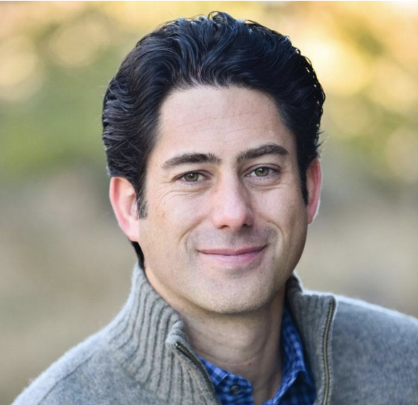
Porter Jones, MD, MBA. Porter Currently serves as the VP of Clinical Transformation at Avant-garde Health where he works with hospitals and surgery centers to implement value-based improvements. Porter is a seasoned healthcare professional with vast experience in hospital administration and the medical device industry. He spent four years at the Albert Einstein Hospital in Sao Paulo, Brazil, where he managed the oncology department as well as the medical practice division. In this role he also oversaw the quality, outcomes, health economics and the medical record departments. Porter is a graduate of The University of Utah School of Medicine and has a business degree from Harvard Business School.

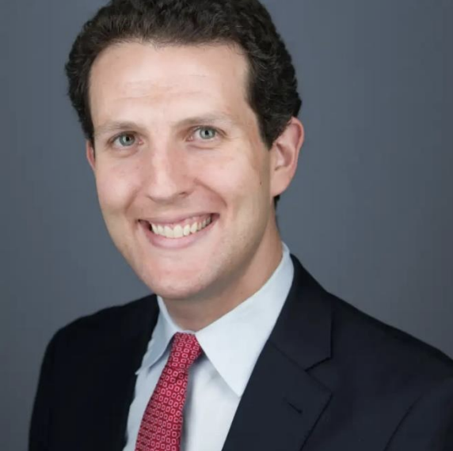
Derek Haas, MBA is the Founder and CEO of Avant-garde Health, a venture-backed company whose mission is to help physicians and hospitals understand and improve care quality and cost across the care continuum. He has written 9 Harvard Business Review articles and been quoted by the Wall Street Journal in a front-page article. Previously, he worked on the staff of the President's Council of Economic Advisers, for Bain & Co, at Harvard Business School, and launched a small business health insurance program in partnership with the Chambers of Commerce in Massachusetts. Avant-garde Health builds on his work as the Project Director and Fellow for Value Based Health Care Delivery at the Harvard Business School, where he works with health care providers to help them better measure and manage their costs. Derek also teaches in HBS executive education courses related to value management in health care. Derek holds an MBA and a BA in Economics from Harvard University, where he was elected to Phi Beta Kappa.

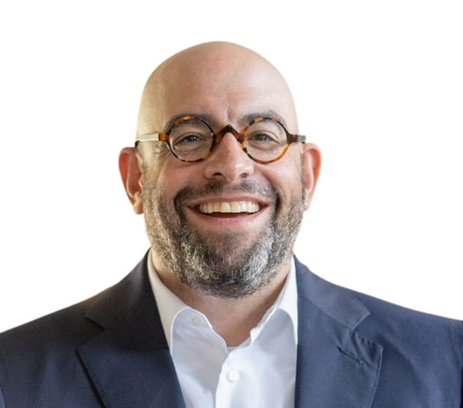

Alan Friedman, Founder and CEO, is a trusted advisor and coach to senior healthcare leaders. His thought leadership has influenced organizations throughout the United States, Italy, France, the United Kingdom, Argentina, Mexico, Guatemala, Australia, and Canada. Since founding J3P Healthcare Solutions, he has led J3P’s extensive research efforts, in collaboration with nationally and internationally ranked academic programs, resulting in numerous publications in high-impact, peer-reviewed journals. He is known as a dynamic and engaging presenter and educator, adept at engaging clinical students, residents, physicians, nurses, and healthcare leaders. His role as executive coach to clinicians and leaders provides the foundation for J3P’s unique approach to individualized development on behalf of
healthcare organizations.

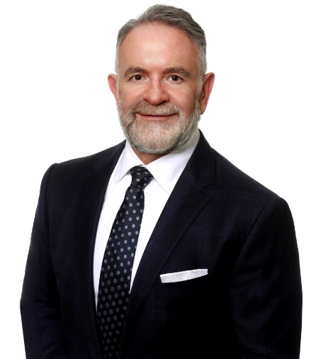

David S. Jevsevar, MD, MBA is CEO Of OrthoVirginia, having joined the organization in 2022. He was previously Chair of the Department of Orthopaedics at the Geisel School of Medicine at Dartmouth and Vice President of the Orthopaedic Service Line for Dartmouth-Hitchcock Health. Dr. Jevsevar has had a long involvement with value-based care including evidence-based medicine, clinical program and care pathway development, quality and performance improvement, and clinical/patient–reported outcomes. He is active within the American Academy of Orthopaedic Surgeons (AAOS), serving as Chair of the Council on Research and Quality and ex-officio member of the AAOS Board of Directors. He is also currently Chair of the American Association of Hip and Knee Surgeons Evidence-based Practice Committee and was previously Vice-President of the New Hampshire Orthopaedic Society. Dr. Jevsevar’s clinical practice is focused on hip and knee arthroplasty.

Tim Lanier, VP & GM - Upper Extremities, Stryker

Tim was appointed VP & GM, Upper Extremities at Stryker in July 2016. He has over with 35 years of medical device and commercial operations experience. His career has taken him through the vascular, oncology, ophthalmology, and orthopaedic arenas. Tim has earned a reputation for building world-class teams and organizations. Tim is laser focused on one thing, “Setting the strategic plan for how we lead in and transform the Upper Extremity market, primarily in the shoulder marketplace.” Tim’s passion for winning is equally reflected in the passion he has for the people he leads.

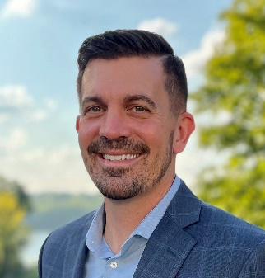

Benjamin A Byers, PhD is the Senior Director of Sports Medicine at DePuy Synthes where he leads its global soft tissue solutions business. With over 17 years of medical device experience spanning both marketing and research & development, Ben’s orthopaedic device career has included experiences in sports medicine, spine, trauma, biologics, and health system marketing. Taking a page from the playbook of his most impactful managers and mentors over a career at Johnson & Johnson, he places a centralized focus on building and cultivating diverse teams that deliver complementary skills and perspectives to enable efficient adaptation to the ever-evolving medical device marketplace.

